Name: Udaybir Singh
Center Name: Strodes College
Candidate Number: 322820
Center Number: 64910

GYM TRACKER

Table of Contents
1 Analysis 3
1.1 Background of problem and identification of prospective users 3
1.1.1 The User 3
1.1.2 Area to be computerised 3
1.1.3 Problem Statement 3
1.1.4 Possible Project Objectives 4
1.2 Research 5
1.2.1 Interviews 5
1.2.2 Direct Observation 7
1.2.3 Internet Search 8
1.2.4 Research conclusion 9
1.3 Initial Modeling 10
1.3.1 List of major variables 10
1.3.2 Files 11
1.3.3 Formulae and calculations 11
1.3.4 Menu Hierarchy/ Initial Screen Layout 12
1.3.5 Object analysis diagrams 13
1.3.6 Data flow diagrams 14
1.3.7 State transition diagrams 14
1.4 Objectives 15
2.Documented design 18

1 Analysis

1.1 Background of problem and identification of prospective users

1.1.1 The User
The user’s name is Udaybir Singh and the primary user is the candidate. The candidate will have full access to the system to test, input data, and evaluate the system frequently.

1.1.2 Area to be computerised
A personal project. The user frequently goes to the gym and needs an effective way to track and monitor gym progress. The area to be computerised is a gym tracking app. The project only focuses on the aspect mentioned. Other gym-going people who need an easy-to-use and free system to track workouts may also benefit from the project.

1.1.3 Problem Statement
Current gym tracking apps are too expensive or ineffective because of confusing UI, and statistics that are not given to the user. Computerisation will help to make a new system that gives all the necessary data, while also giving intuitive UI.

1.1.4 Possible Project Objectives
- Log workouts, tracking reps, exercise, weight, time taken, and water intake.
- Have preset workouts to choose from and change reps and weight accordingly.
- Delete, modify, and add preset workouts.
- View workout history.
- Display important information (progressive overload, total volume over time, frequency, consistency, and progressive overload).
- Recommend advice based on data given by the user (e.g., when to move up weight).
- Give warnings based on data given by the user (de-load weeks, over training warning).
- An exercise database with muscle group categorisation.
- Intuitive UI.
- Add custom exercises.
- Allow data to be saved as a PDF file.
- Login and sign-up system with passwords and usernames, saving important data for that user so progress can be saved even after closing the program.

1.2 Research

1.2.1 Interviews
Interview before the development of the project(09/02/2026, 11:30-11:40)
1.How do you track your current workouts(notepads, phone app, memory)?
Currently I use the notes app on my phone to track the weight and reps I done for a specific exercise.
2.How much time do you spend logging or recording your workouts now?
Currently I spend not that much time I just have the find the notes page and update it
3.What problems have you experienced with tracking your progress?
Sometimes I forget to track my reps on the notes app and it gets a bit confusing.
4.Have you used any gym apps before? If yes, what did you like or dislike about them?
I have used an app called Iron notes but it just didn’t have all the features I wanted. And the UI was very overwhelming for me
5.What features do you think are missing in the apps you have used?
The features that are missing are good UI, the data it gives me is not enough I want information on progressive overload, my personal records and more.
6.Which data do you want to record for each workout?
For each workout I want to be able to set the exercise to currently doing and when I finish a set it gives me a reminder to do another set after the rest period. I want to be able to change the reps based on what I did and the weight if I have changed it from the previous session.
7.Do you want the system to give you reminders based on your workouts?
Yes, I really like this idea because it can help me stay on track. Like maybe it reminds me to drink water and reminds that my rest period has ended. Or even tells me that I have a muscle group I am not training.
8.How important is it for the app to have an intuitive UI system?
This is very important personally because I find my biggest issue with gym tracking apps is that the UI is very confusing. Even after using it for a while its very complicated.
9.Would you like preset workouts or would you like to create your own?
I would like to create my own to support my bodybuilding goals.
10.Would you want to see your progress displayed visually?
Yes I think this would be great for staying focused and motivated.

Interview after development of UI and save and load file (18/02/26)
1.What do you think about the UI design?
The client said they liked the simplistic black and white UI they saw for the save and load file. So I will maintain this design throughout the program
2.What do you think about the save and load file
The client also liked the save and load file saying it worked perfectly however he also wanted password hashing which I will implement in the next version of the project.
3.What do you think about the popup screen when incorrect data inputted?
The client likes the popup as it displays errors clearly to him
4.Is it easy to navigate between screens
The clients like the navigation as it is easy and there are back buttons to go back to previous versions
5.Are the input boxes easy to use for the save and load file?
The client likes the input boxes as it’s clear where to input what data
Interview conclusion
Overall, the user likes the current system as it is designed in a simplistic way which he mentioned he preferred in the initial interview. The current saves and load file needs to have a hashing system for the passwords as the client wants more security. The navigation is fine for the user and input boxes read clearly and they know where to input what data

1.2.2 Direct Observation
An observation of the user using his current method to track his progress:
4:00PM, Staines-Upon-Thames Pure-gym, 1:30 duration.
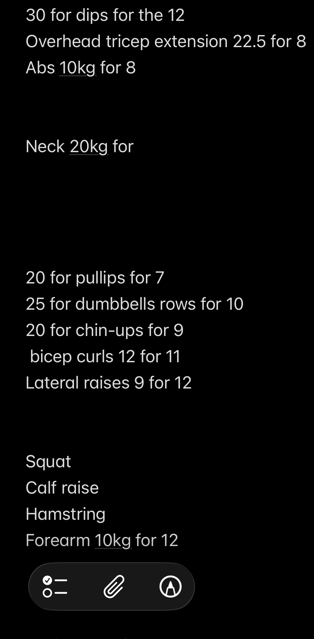
From the observation, I saw the user would manually rewrite his notes to update the reps and weight. However, the user only logs the first set and does not log the rest of the sets. Also, in the notes he was using to track, no important statistics were given to the user to help them stay motivated and better track their progress. Furthermore, from the initial interview (1.2.1), the user has a hard time tracking the rest time between sets, which wastes time in his session. This is why he wanted to implement a rest time timer with reminders.

From figure 1.2.2.1 we can clearly see the users way of organising his lifts are disorganised and confusing as you cant see the reps and weight done clearly. Furthermore there is not important data being displayed, reminders, or any of the features the user wanted in the new program.

Figure 1.2.2.1. Picture of clients current tracker.

1.2.3 Internet Search
After searching for “workout tracker apps” on the internet a lot of apps already exists. The best one I found for the user was Iron Notes which he stated using before. However it does not allow for custom exercises to be added so the user couldn’t track his progress on them. He also said he thought the UI was very confusing and he couldn’t see a clear overview of his progress displayed visually.
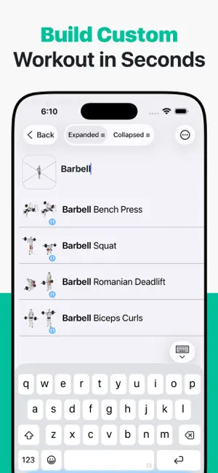
From the screenshot in figure 1.2.3.1 you can see the app has a database of exercises however there is no option to create a custom workout which the user would like.

Also in figure 1.2.3.2 we can see that it gives reminders to the user based on his workout. It states that the user Is fatigued and that his progress has declined showing graphics and percentage to display it better to the user.
Figure 1.2.3.1 Picture from IronNotes app
Figure 1.2.3.2
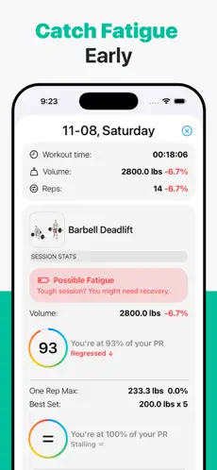

Figure 1.2.3.2 Picture from IronNotes app

1.2.4 Research conclusion
Based on all the information I have gathered I can conclude that are some good options out there for the user for example IronNotes(1.2.3 Internet Search). However, these do not include all the features the user wanted stated in initial interview (1.2.1). The user wants to be able to track progressive overload, add custom exercises, track records and receive rest period reminders. Some of these features are implemented in IronNotes however the user wants all of the features and a more intuitive UI. The Direct Observation (1.2.2) showed the users current method to track progressive overload and gym statistics. The user was using the notes app to manually rewrite his data which is long winded and inefficient. Therefore, the project will create a workout tracking application with effective UI and provides all the missing features the user requires.

1.3 Initial Modeling

1.3.1 List of major variables
Exercise database (dictionary). Variables being stored inside are:
Exercise_name | str | To store the name of the exercise
muscle_group(array) | Str | To store the muscles the exercise trains
Muscle_amount_trained | int | 3 values to show how intensely the muscle is being trained(for bicep curls the main muscle trained is biceps but forearms trained too. So biceps would be 3 and forearms would be 2

1.3.2 Files
For the files I will have a folder for graphics and then store the workout database and user database as SQLite3 files.
Furthermore the user will be able to turn there statistics from the app into a png. This enables printing or external sharing of workout achievements.

1.3.3 Formulae and calculations
Total volume for movement = sets*reps*weight

1.3.4 Menu Hierarchy/ Initial Screen Layout
The program will run on one main screen but the state will change. Eg from login to dashboard. To make the different screens consistent ill make a class for reusable objects like text, panels so the design is repeated throughout the project.
Entry screen:
logo

Log in

Sign up

exit

Log in screen Sign up screen
LOG IN
SIGN UP

username
username
input
input

password
password
output
output

BACK
BACK
This is the log in system design im going to do. Its simplistic and reads clearly

1.3.5 Object analysis diagrams

1.3.6 Data flow diagrams

1.3.7 State transition diagrams

1.4 Objectives
1) Basic Workout Logging
- Record exercises, sets, reps, and weight for each workout
- Track workout duration and completion time
- Add notes and comments to individual workout sessions
2) Custom Exercise Management
- Add custom exercises not in the default database
- Edit exercise names and details
- Delete exercises from personal library
3) Workout Templates
- Create preset workout routines
- Modify existing workout templates
- Delete unwanted workout templates
4) Rest Time Tracking
- Log rest periods between sets
- Track total rest time per workout
5) Water Intake Monitoring
- Record water consumption during workouts
- View hydration trends over time
6) Workout History
- View all completed workouts in chronological order
- Filter workouts by date, exercise, or muscle group
- Search through past workout sessions
7) Personal Records (PRs)
- Automatically calculate PRs for each exercise
- Display current PR for weight lifted
- Show when PRs were achieved

8) Volume Tracking
- Calculate total volume per workout (sets × reps × weight)
- Track volume changes over weeks and months
- Display volume trends for specific exercises
9) Progress Visualization
- Generate graphs showing strength improvements
- Display charts for volume progression
- Create visual timelines of workout frequency
10) Strength Gain Analysis
- Track strength increases per exercise
- Calculate percentage improvements over time
- Compare strength across different muscle groups
11) Consistency Monitoring
- Track workout frequency (workouts per week/month)
- Identify workout streaks and breaks
- Display attendance patterns
12) Progressive Overload Tracking
- Monitor if weights are increasing appropriately
- Track progression rate for each exercise
- Highlight plateaus in training
13) Weight Progression Recommendations
- Suggest when to increase weight based on performance
- Calculate recommended weight jumps
- Provide guidance on progression speed
14) Recovery Management
- Recommend de-load weeks based on training volume
- Suggest rest days when needed
- Track recovery periods between workouts

15) Over training Detection
- Monitor training volume and frequency for warning signs
- Alert users when training intensity is too high
- Track fatigue indicators
16) Muscle Balance Analysis
- Identify if certain muscle groups are under trained
- Compare volume across opposing muscle groups
- Suggest exercises to address imbalances
17) Exercise Database
- Provide library of common exercises
- Categorize exercises by muscle group
- Include form tips and instructions
18) Data Export
- Export workout history as PDF
- Generate progress reports
- Save data for external use
19) User Authentication
- Secure login with username and password
- Sign-up system for new users
- Password encryption and security
20) Data Persistence
- Save all user data to their account
- Maintain progress across sessions
21) User Interface
- Clean and intuitive design
- Easy navigation between features
- Responsive layout
- Reusable class for User Interface
- Simple and easy to use interface

2.Documented design

2.1 Overall System Design
The programming language to be used is python using customtkinter for the graphics. Im using SQLite 3 database and using json.

2.2 Classes

